Lesson 2:

4. d) SELECT [ProductSubcategoryID], MIN(Weight) AS min_weight, MAX(Size) AS max_size

FROM [Production].[Product]

GROUP BY [ProductSubcategoryID]

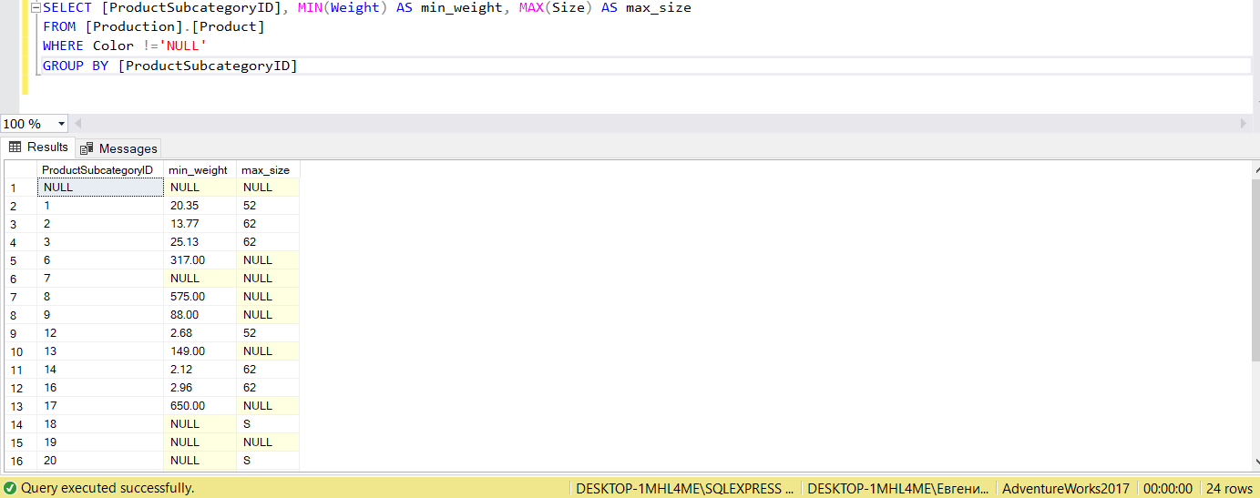

4. e) SELECT [ProductSubcategoryID], MIN(Weight) AS min_weight, MAX(Size) AS max_size

FROM [Production].[Product]

WHERE Color !='NULL'

GROUP BY [ProductSubcategoryID]

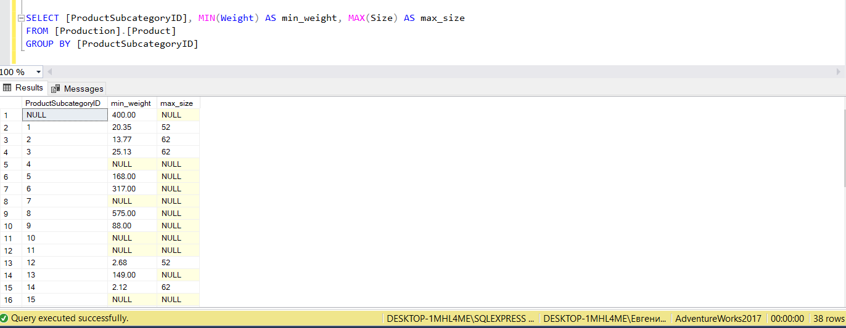

Lesson 3

2.a) SELECT [Name],

CASE WHEN [StandardCost] = 0 OR [StandardCost] = NULL THEN 'Not for sale'

WHEN [StandardCost] > 0 AND [StandardCost] < 100 THEN '<$100'

WHEN [StandardCost] >= 100 AND [StandardCost] < 500 THEN '<$500'

ELSE '>=$500'

END PriceRange

FROM [Production].[Product]

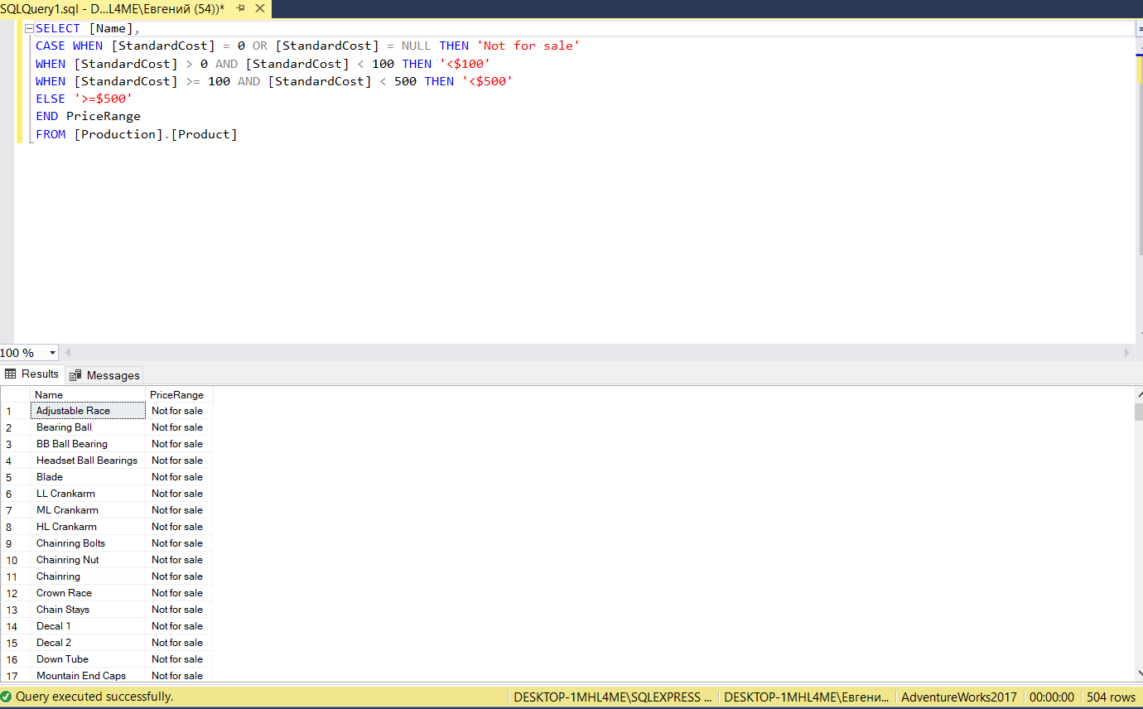

2.b) SELECT [Purchasing].[ProductVendor].[ProductID], [Purchasing].[ProductVendor].[BusinessEntityID], [Purchasing].[Vendor].[Name]

FROM [Purchasing].[ProductVendor]

LEFT JOIN [Purchasing].[Vendor] ON [Purchasing].[ProductVendor].[BusinessEntityID]=[Purchasing].[Vendor].[BusinessEntityID]

WHERE [StandardPrice] > 10 AND [Name] LIKE '%X%' OR [Name] LIKE 'N%'

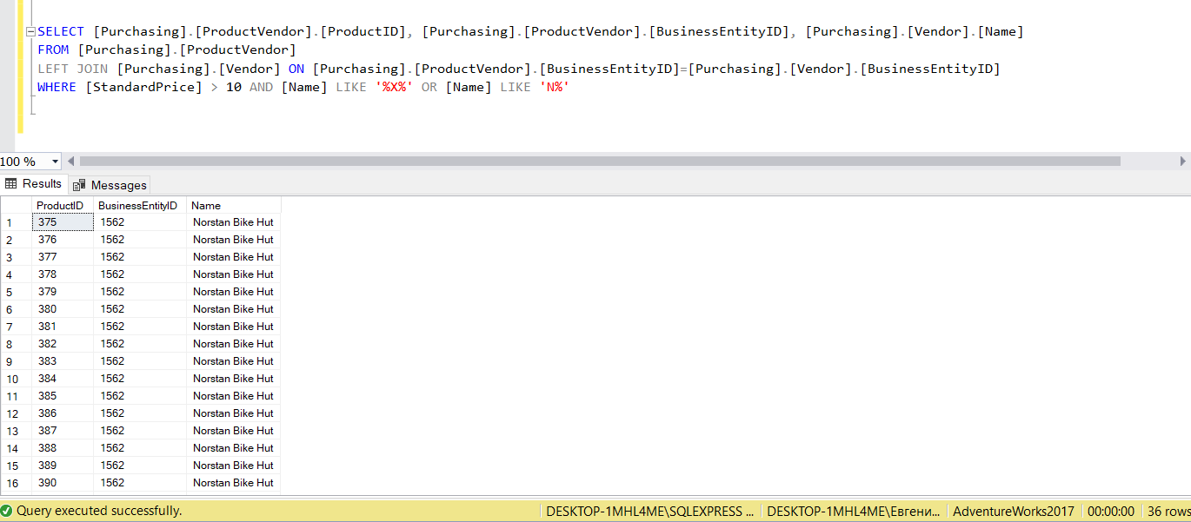

2.c) SELECT [Purchasing].[Vendor].[Name]

FROM [Purchasing].[Vendor]

LEFT JOIN [Purchasing].[ProductVendor] ON [Purchasing].[ProductVendor].[BusinessEntityID]=[Purchasing].[Vendor].[BusinessEntityID]

WHERE [OnOrderQty] = 0

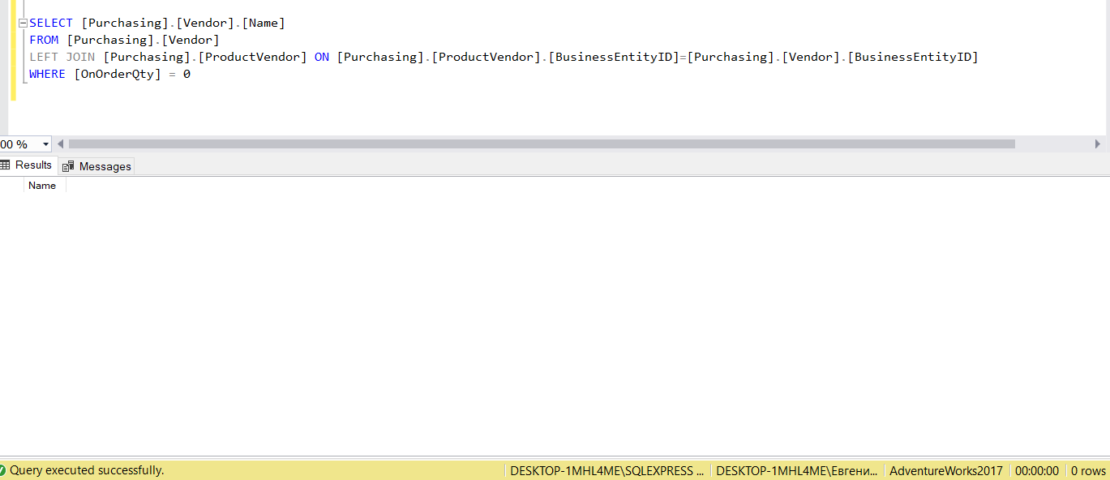

3.a) SELECT DISTINCT [Production].[ProductModel].[Name], [Production].[Product].[StandardCost]

FROM [Production].[ProductModel]

LEFT JOIN [Production].[Product] ON [Production].[ProductModel].[ProductModelID]=[Production].[Product].[ProductModelID]

WHERE [Production].[ProductModel].[Name] LIKE 'LL%'

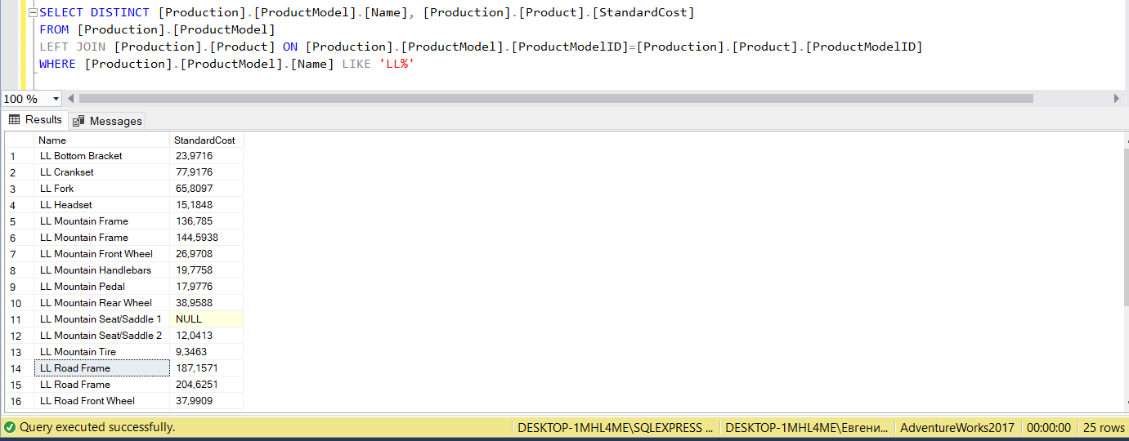

3.b) SELECT DISTINCT [Name]

FROM [Purchasing].[Vendor]

UNION

SELECT DISTINCT [Name]

FROM [Sales].[Store]

ORDER BY Name

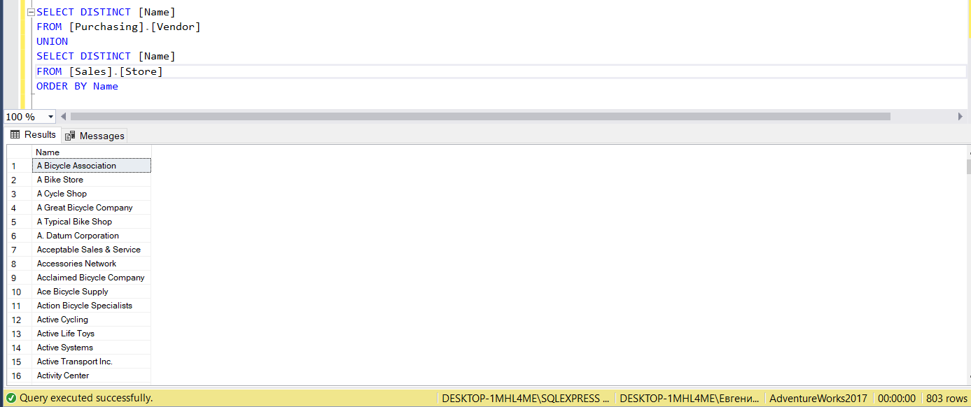

3.c) Получилось решить только таким способом

SELECT [Production].[Product].[Name]

FROM [Production].[Product]

LEFT JOIN [Sales].[SpecialOfferProduct] ON [Production].[Product].[ProductID]=[Sales].[SpecialOfferProduct].[ProductID]

LEFT JOIN [Sales].[SpecialOffer] ON [Sales].[SpecialOfferProduct].[SpecialOfferID]=[Sales].[SpecialOffer].[SpecialOfferID]

WHERE EXISTS

(SELECT [ProductID], COUNT([SpecialOfferID]) AS special_offer FROM [Sales].[SpecialOfferProduct]

GROUP BY [ProductID]

HAVING COUNT ([SpecialOfferID]) > 1)

